Test Summary Report: Restful Booker API Suite
Project Information
Item Details
Project Name Restful Booker API
Test Phase Transition: Manual Testing to Automated Regression
Test types Functional, Security, Integration, Schema Validation, Authentication, Negative Bounds
CI/CD Platform Jenkins
Reporting Tool Allure Report and Newman HTML Report
Prepared By: Amrutha M

1.Executive Summary
The Restful Booker API test suite was executed successfully to validate the core booking functionalities including health check, authentication, booking creation, retrieval, update, and deletion operations. Testing transitioned from a manual exploratory baseline using Postman to Python regression automation framework.
The automation suite covered API response status codes, payload validation, authentication token generation, booking CRUD operations, schema validation, response headers, response time checks, and negative scenarios.
The results show that most API operations function as expected, while a small number of failures were identified during testing and classified as validation issues or product defects.

2.Test Execution Summaries
- Excel Workbook : 40 Logical test Cases
- Postman : 47 Assertions executed via pm.test() across requests (multiple granular
validations)
- Pytest : 20 Consolidated, multi-assertion automated methods

2.1 Postman Collection
- Total Assertions executed: 47
- Successful Assertions: 40
- Failed Assertions: 7
- Pass rate : 85.1%
- Total Iteration: 1
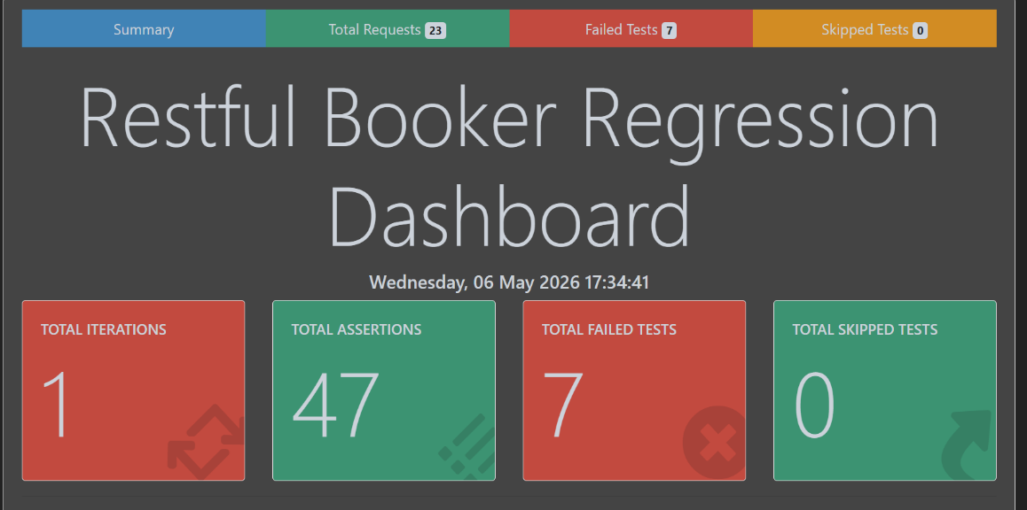
Note: Screenshot from Newman Summary HTML Report
2.2 Python + Pytest (Automated Regression Suite)
- Total tests executed: 21
- Failed tests: 4
- Pass Rate : 80.95%
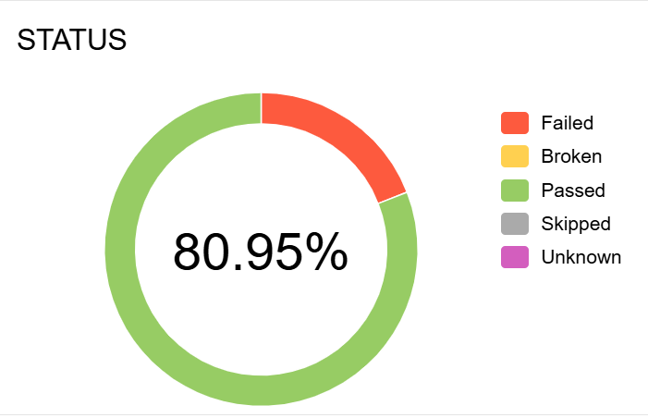
Note: Screenshot from Allure Report
The Python suite consolidates the 47 Postman assertions into 20 structural, high efficiency test cases. Each Python test leverages multi assertion hooks to validate status codes, payloads, headers and schemas simultaneously.

3. Functional Coverage Map
API Module | Test Focus  Coverage | Manual Status  (Postman) | Automation Status (Pytest) | Notes/Comments
Health Check | GET/ping | Pass | Pass | Fully automated.  Validates HTTP  201 response
Authentication | POST/auth | Pass | Pass | Automated core  validation loops
Get Booking | GET/booking/{booking_id} | Pass | Pass | Automated happy  paths and filtering
Create Booking | POST/booking | Failed | Failed | Fails when  validating missing fields,incorrect datatypes and  invalid date order
Update booking | PUT/booking/{booking_id}  PATCH/booking/{booking_id} | Failed | Passed | Malformed token  bypass failed in  Postman but  returned expected  results in python
Delete booking | DELETE/booking/{booking_id} | Failed | Failed | Deleting a non-  existent ID  incorrectly returns 405 Method Not Allowed instead of 404 Not Found

4. Defect Log & Analysis
Defect 1: Create Booking with Missing Required Fields
- Test Case ID Reference: RB_003_TC05
- Target Endpoint: POST /booking
- Payload Sent: Payload completely omitting mandatory fields (e.g., lastname).
- Expected Response: 400 Bad Request.
- Actual Response: 500 Internal Server Error.
- Severity: Medium
Defect 2: Invalid Data Types Accepted on Booking Creation
- Test Case ID Reference: RB_003_TC06
- Target Endpoint: POST /booking
- Payload Sent: ‘totalprice’ passed as an alphabetic string rather than an integer
- Expected Response: 400 Bad Request with appropriate validation errors.
- Actual Response: 200 OK (The API accepted the payload and created a corrupt database record).
- Severity: High / Data Integrity Error
Defect 3: Create Booking with Wrong Date Sequence
- Test Case ID Reference: RB_003_TC07
- Target Endpoint: POST /booking
- Payload Sent: Check-out date set earlier than check-in date (e.g., check-in: 2019-01-01, check-out: 2018-01-01).
- Expected Response: 400 Bad Request.
- Actual Response: 200 OK (The API accepted the logical chronological error).
- Severity: Medium / Business Logic Violation
Defect 4: Incorrect Method Error Returned on Non-Existent Resource Deletion
- Test Case ID Reference: RB_006_TC06
- Target Endpoint: DELETE /booking/99999 (ID does not exist)
- Expected Response: 404 Not Found.
- Actual Response: 405 Method Not Allowed.
- Severity: Medium / API Spec Contradiction

Defect 5: Deleting an Already Deleted Booking Returns Incorrect Method Error
- Test Case ID Reference: RB_006_TC07
- Target Endpoint: DELETE /booking/{booking_id} (Request executed a second time on a successfully deleted ID)
- Expected Response: 404 Not Found.
- Actual Response: 405 Method Not Allowed.
- Severity: Medium / API Spec Contradiction
The following security anomaly was intercepted during manual testing but returned its expected, secure status code during Python execution, illustrating environment volatility:
Defect 6: Malformed Token Authorization Leak
- Test Case ID Reference: RB_005_TC09
- Target Endpoint: PUT /booking/{booking_id}
- Input Provided: Invalid/Malformed Token (Cookie: token=invalid123)
- Expected Behavior: 403 Forbidden
- Observed in Postman: Fail (Returned 200 OK and bypassed security).
- Observed in Python: Pass (The sandbox correctly returned 403 Forbidden, validating the security assertion).
- Severity: Critical (If reproducible in production environments)

5. CI/CD Integration (Jenkins Pipeline)
The automation framework was integrated with Jenkins to enable continuous regression execution and automated reporting. Jenkins marks the build status with a red fail indicator not due to compiler/path issues, but because the automated test suite successfully detected active functional bugs in the application sandbox.

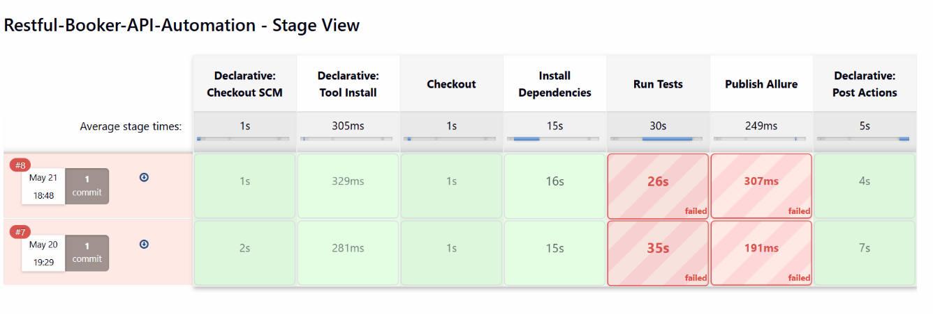
Note: Jenkins Stage View Screenshot

6. Key Observations & QA Insights
- Stable Core Logic: The API's happy-path operations run exceptionally well. Response latency consistently falls >500 ms under single-user load.
- Weak Data Validation Edge Cases: The application relies on the client to send correctly typed payloads and does not check incoming inputs at the API gateway layer. This results in corrupt records (e.g., string types inside price fields).
- CI Pipeline Integration Value: Executing this suite as a Jenkins step proved its value immediately. If this pipeline were linked to a live deployment, it would have blocked releasing these critical security vulnerabilities into a production environment.

7. Exit Criteria Status
Exit Criterion | Status | Remarks
Planned manual and automated test cases are executed | Met | Both Postman and Python automation suites were run successfully.
Critical defects are identified and documented | Met | Validation issues and response mismatches were recorded.
Test reports are generated successfully | Met | Newman HTML and Allure reports were produced.
Test coverage meets the project objective | Met | Core booking APIs, authentication, schema, and negative scenarios were covered.

